

**UNIVERSITI MALAYSIA PAHANG**

**FACULTY OF COMPUTER SYSTEM & SOFTWARE ENGINEERING**

**DCS1093**

**SYSTEMS ANALYSIS & DESIGN**

**SOFTWARE REQUIREMENT AND DESIGN**

**(SRD)**

|  |  |
| --- | --- |
| **GROUP MEMBERS:** | **PIRASANNAH D/O RAVINTHARAN CC11215**  **AFIFAH BINTI MOHAMAD SAKRI CC11294**  **AMIRAH HUSNA BINTI ABU CC11126**  **NURHANNAH MAISARAH BINTI KHAIR JOHARI CC11266** |
| **SECTION:** | **C23** |
| **LECTURER:** | **EN. ZULFAHMI TOH** |

Software Requirement and Design Document

[Transport Rental System]

Version 1.0 ● [30 November 2012]

Software Requirement and Design Document

[Transport Rental System]

Version 1.0 ● [30 November 2012]

Preparation & Edition History

|  |  |  |  |
| --- | --- | --- | --- |
| **Name** | **Date** | **Reason for Change** | **Version** |
| PIRASANNAH D/O RAVINTHARAN | 30 November 2012 | Initial release of SRD | 1.1 |
| AFIFAH BINTI MOHAMAD SAKRI |

**Approval History**

|  |  |  |  |
| --- | --- | --- | --- |
| **Name** | **Date** | **Reason for Change** | **Version** |
| AMIRAH HUSNA BINTI ABU | 11 Sept 2012 | Addition of Preamble Content and Appendices | 1.2 |
| NURHANNAH MAISARAH BINTI KHAIR JOHARI | 16 Sept 2012 | Minor updates to text and systems diagrams | 1.3 |

**TABLE OF CONTENT**

|  |  |
| --- | --- |
| 1 | Introduction |
| 1.1 | Objectives |
| 1.2 | Design Concept |
| 1.3 | Modules |
| 1.4 | Development Environment |
|  |  |
| 2 | [Software Name] |
| 2.1 | Functions |
| 2.2 | Sub-modules |
| 2.3 | System Flow Diagram |
| 2.4 | Use Case Diagram |
| 2.5 | Context Diagram |
| 2.6 | Data Flow Diagram |
| 2.7 | User Interface |
|  |  |
| 3 | Conclusion |

1. **INTRODUCTION**
   1. **Objectives**

For this system, there have many kinds of objectives that consider on, there are:

1. Arrange the data systematically.
2. Provide a level for finding customer information.
3. Can save time and manpower.
4. That can save a lot of manpower

* 1. **Design Concept**

User friendly

* This system is easy to understand it because the interface for this system is simple. This system is easy to use. If the people want to use this system, they must key in their id number and the password. Then, it will bring us to the page menu. If user want rent the transport they must key in the date and time they want to start rent and date and time end.

Functionality

* The tasks that the software can perform and the mandatory, essential, and desired system feature. For example it can delete, add, move and edit data.

International standards

* A system that follows the international standards that have the functionality of renting cars, manage user and customer information and balancing the drivers workload.

Response time

* This system did not take long time to access the result.

Ease to installation

* This system also connected us to the internet. So that, the customer easy to access in this system through the internet. We take 3 month to finish this project.
  1. **Modules**

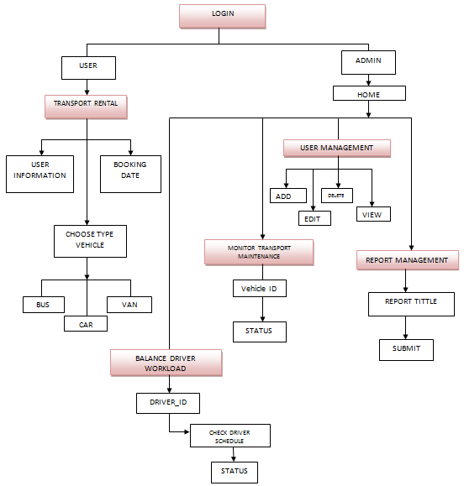

* 1. **Development Environment**

1. **Hardware Requirements.**

This section only details the hardware required to run the base Oracle Transportation Management application. It does not take into account additional Oracle Transportation Management components or third-party components and it is not a configuration for high volume or complex or complex implementations. To determine the correct configuration for the production, test and development environments, should work with the hardware and/or implementation consultants.

**Web user**

You must have a computer capable of running one of the supported browsers. Many factors will affect the performance experience of the end-user,including: CPU type & speed; operating system version; available memory; hard drive speed; network card speed, and network bandwidth between the browser and the web server.

**Test and Development Servers**

* Combined Web & App: 2 x 3.0 GHz dual-core Xeon CPU, 6 GB RAM, 40 GB disk

**Production and Development Servers**

* Web Server: 2 x 2.5 GHz quad-core Xeon CPU w/ 18 MB cache, 6 GB RAM, 80 GB disk
* Application Server: 2 x 2.5 GHz quad core Xeon CPU w/ 18 MB cache, 8 GB RAM, 80 GB disk

1. **Software Requirements for Oracle Transportation Management Server Configurations**

* 64-bit Windows Server 2008 R2 Enterprise x64 Edition with the latest Service Packs, OR
* 64-bit Windows Server 2008 Standard Edition with the latest Service Packs
* Oracle 11gR2 (11.2.x) Database Enterprise Edition
* Oracle Weblogic Server Standard Edition 11gR1 (10.3.3.x)
* Integration Server – EAI solution (optional)

The following software is distributed with Oracle Transportation Management:

* Apache Web Server 2.2.16
* Tomcat Java Servlet Server 6.0.18
* OpenSSL 0.9.8o
* Zlib 1.2.3
* 64-bit JRockit JDK 1.6.0_20(R28.0.1)
* Python 2.4.2

1. **Transport Rental System**
   1. **Functions**

The following are the functions of the Transport Management System:

1. The system is programmed to optimize the use of time and resources.
2. This system also provided of balancing the driver workload where the customer and drivers have balanced chance to rent the transport.
3. The management teams were responsible to monitor the rental process and the condition of each vehicle must be in good condition throughout their service.
4. The management teams also enable to maintain the user id by creates, edit view and delete the user id that had registered by the user to the system.
5. The transport management system needs to provide the list of report for the use of management system.
6. The customer and university’s staff will be able to access the rental system through online by creating their user account.
   1. **Modules Detail**



**Login**

* The user will enter this software with log in with their number ID and and password and also choose their type whether user or admin and then they can acess aour software.

**Transport rental**

* This module is use by user after they log in this system. They can book a rental of vehichle with just fill their information in **user information** and they can choose **type of vehichle** and give some rental date information in **booking date.**

**Balance driver workload**

* This module is to be able to assign driver to each customer rental and maintain balance among all drivers. This software will apply for **driver ID** and **vehichle ID** to detect the **driver schedule** and give the driver **status** wheter the driver is available or not.so, the user will get the driver for each transport.

**Monitor transport maintenance**

* This module is to guarantee the safety of all customers and this software provides a system that can survey transport in early to identify that transport in good condition or in services. In our software the admin can enter the **Bus_ID** , **Van_ID and Car_ID**  and this system will show the **status** of the transport.

**User management**

* In this modules the admin can rental the information of user such as they can add, edit, delete and view the information. When the user click the add button it will give a form to be fill about new user. Then if the admin want to edit the information they can click on edit button and to delete the information the admin can click on deleteb utton and dialog box will appear to ask whether are you sure want to delete and press ok to delete all information. The last button in our system is to view the user information.

**Reporting rental**

* This module must propose meaning report tittle that are critical in the transportation business.Then in our system we provide the report tittle and space to describe about transport and the admin can submit that report in this system.
  1. **System Flow Diagram**

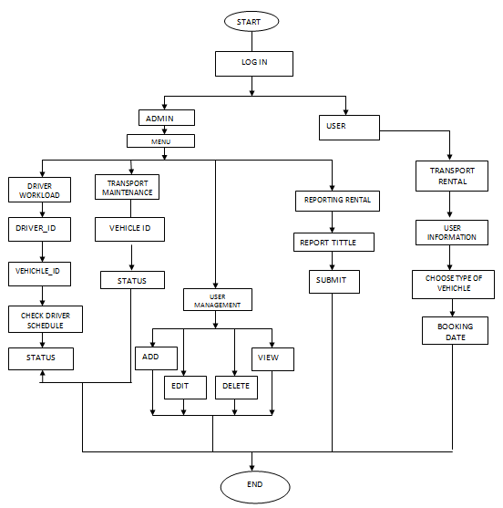

* 1. **Use-case Diagram**

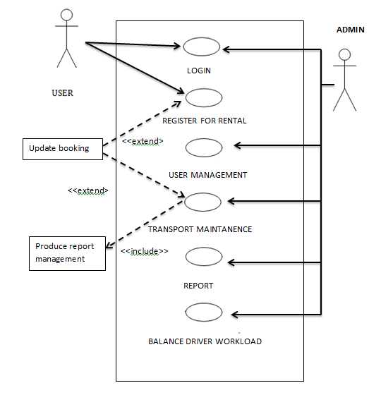

* 1. **Context Diagram**

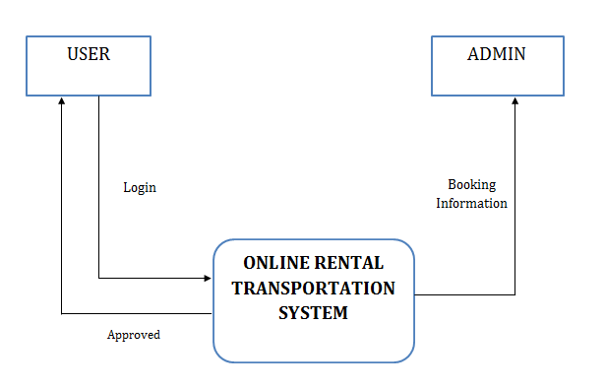

* 1. **Data Flow Diagram (DFD)**

**DFD Balance Driver Workload Level-0**

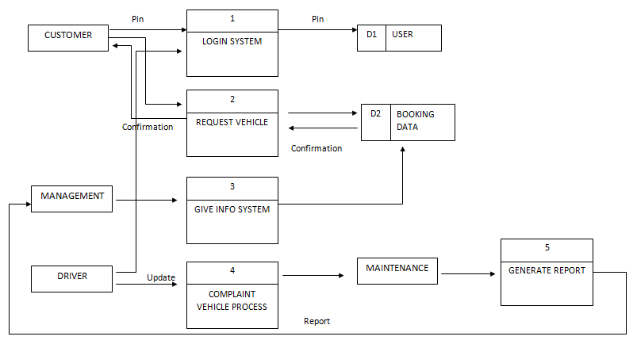

**DFD User Management Level-0**

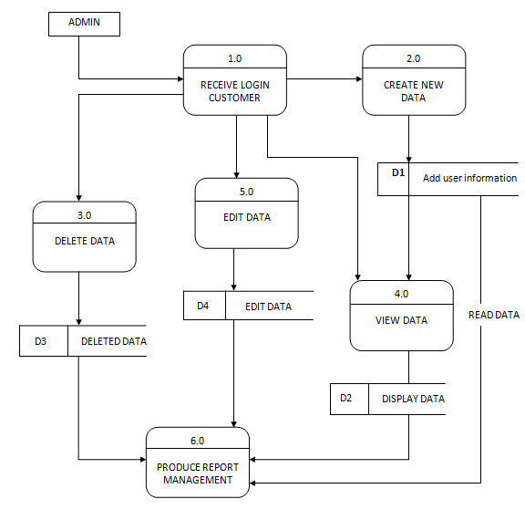

**DFD Transport Rental Level-0**

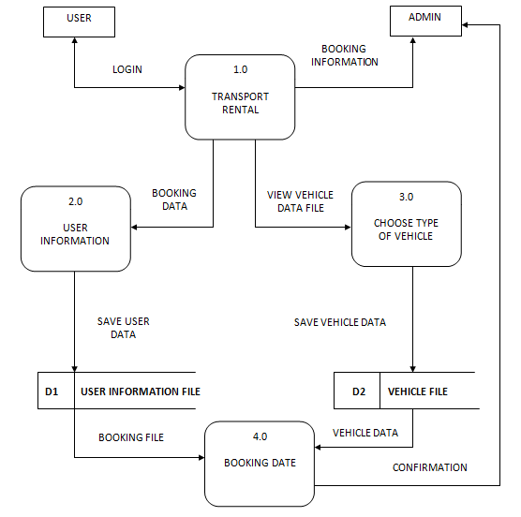

**DFD Report Management Level-0**

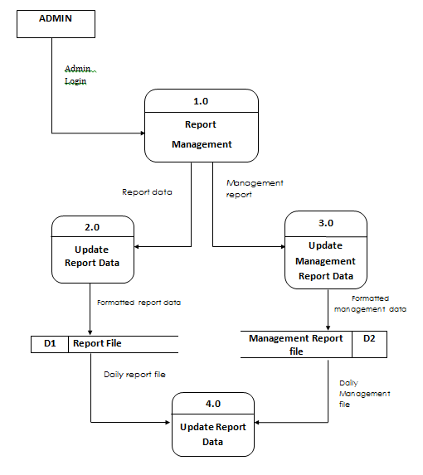

**DFD Monitor Transport Maintanance Level-0**

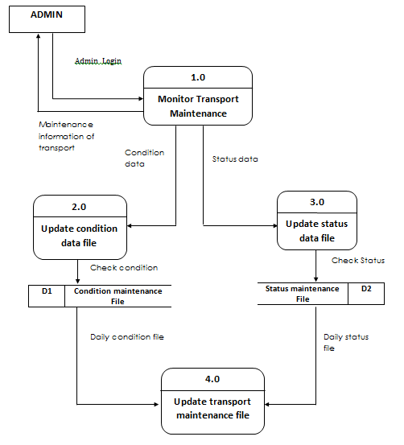

* 1. **User Interface**

**USER**

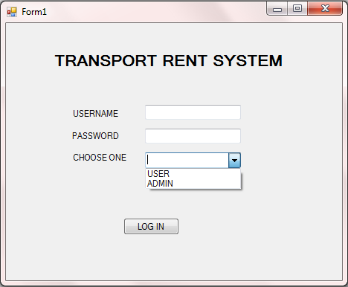

**Figure 1 : Main page**

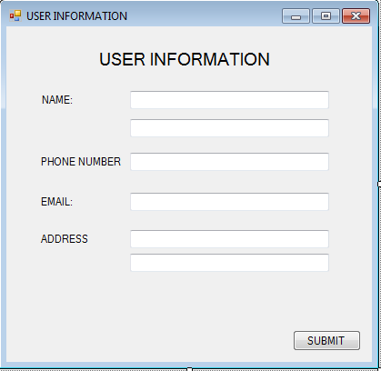

**FIGURE 2 : USER INFORMATION PAGE**

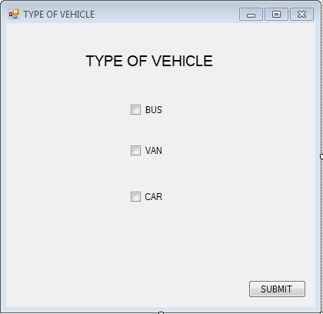

**FIGURE 3 : USER CHOOSE TYPE OF VEHICLE PAGE**

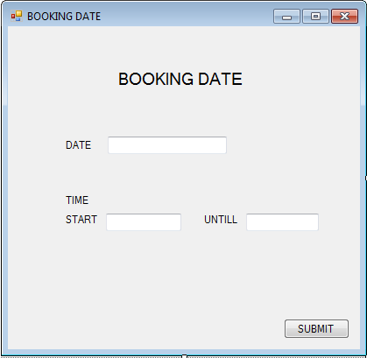

**FIGURE 4 : USER BOOKING DATE PAGES**

**ADMIN**

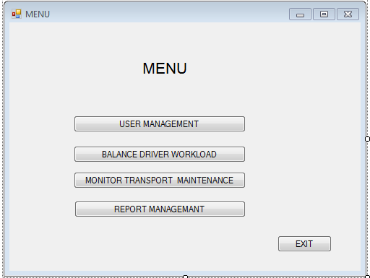

**FIGURE 5 : MENU PAGE**

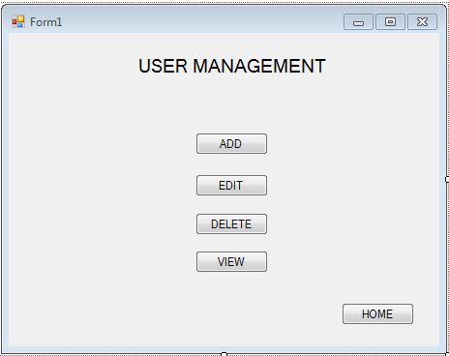

**FIGURE 6 : USER MANAGEMENT PAGE**

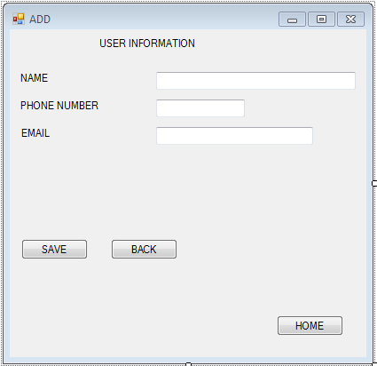

**FIGURE 7 : ADD USER INFORMATION PAGE**

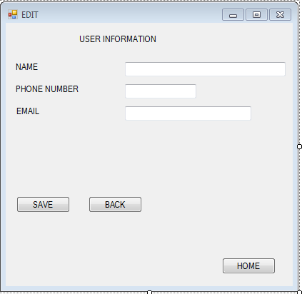

**FIGURE 8 : EDIT USER INFORMATION**

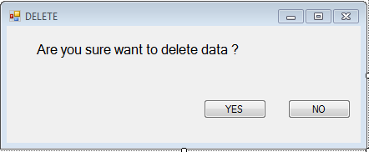

**FIGURE 9 : DELETE USER INFORMATION**

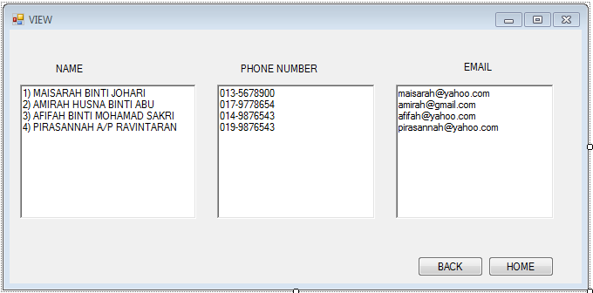

**FIGURE10 : VIEW USER INFORMATION PAGE**

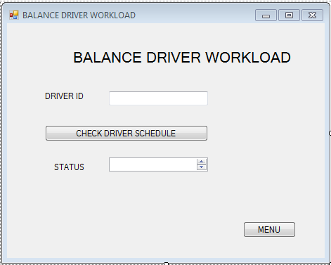

**FIGURE 11 : BALANCE DRIVER WORKLOAD PAGE**

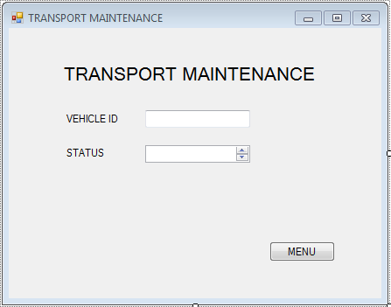

**FIGURE 12 : TRANSPORT MAINTENANCE PAGE**

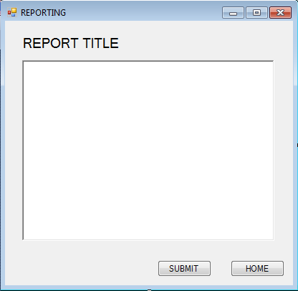

**FIGURE 13 : REPORT VEHICLE PAGE**

**3.0 CONCLUSION**

We gain a lot of experience and lessons from this project. First of all, we have learnt how to using SQL and make a user-friendly and interesting interface. Our system is use for customer registration and making reservation systematically by a JHEPA where can save a lot of man power and time.

We also find out that teamwork is very important in this project. This project requires team member’s to work together to achieve the goal. Without teamwork, we are unable to complete this project. We have to face some problem while develop this project, such as creating the interface and the coding problem to link the entire interface together. So, we will have a discussion to discuss among group member to figure out a best solution for our problem.

Lastly, we also know about requirement how to motivate and synchronize the assigned resources to achieve the goals of our project, while coping with the constraints of time, cost, and consistent quality. We all manage projects from the start until it finish. We learn more about the steps on how to handling the projects organization within a systematic framework, utilizing appointed or allocated resources. The tasks are subject to dependencies, such as the performance of others and risks that can go wrong. We are able to obtain on how to possess a variety of problem-solving, communication, motivational, visionary, and team-building skills to make our project going smoothly based on the project schedule.